**Project Report 6**

K-Means Clustering: Image Segmentation

Name: Dhivakar .R

Course: AI and ML (Aug 2020)

**Question**:

Take a bright colorful image (Eg: image having fruits in it) and implement image segmentation using K-Means. You can first try to implement K-Means on iris dataset to understand its working and then extend the same logic, using the image pixels as the data points. Hint: All the K centroids will represent a color and therefore, you can initialize all the pixels to belong to a cluster randomly and then start the training of the centroids.

**Prerequisites**

What things you need to install the software and how to install them:

Python 3.6 This setup requires that your machine has latest version of python. The following url <https://www.python.org/downloads/> can be referred to download python. Once you have python downloaded and installed, you will need to setup PATH variables (if you want to run python program directly, detail instructions are below in how to run software section). To do that check this: <https://www.pythoncentral.io/add-python-to-path-python-is-not-recognized-asan-internal-or-externalcommand/> . Setting up PATH variable is optional as you can also run program without it and more instruction are given below on this topic.

Second and easier option is to download anaconda and use its anaconda prompt to run the commands. To install anaconda check this url <https://www.anaconda.com/download/> You will also need to download and install below 3 packages after you install either python or anaconda from the steps above Sklearn (scikit-learn) numpy scipy if you have chosen to install python 3.6

**Importing the libraries and loading dataset.**

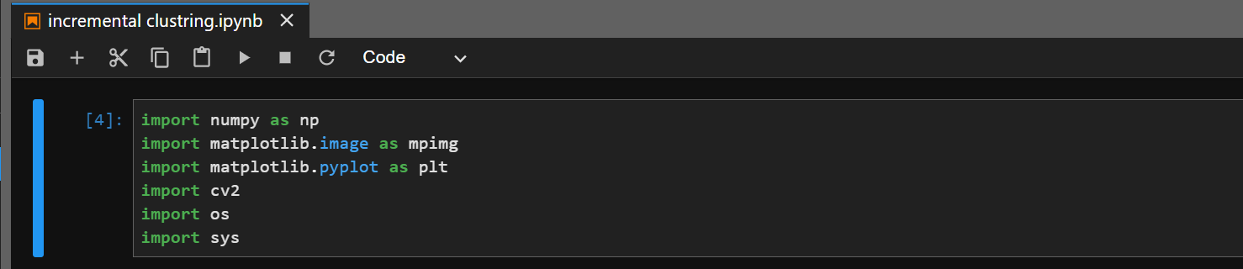

**func to initialize mean and variance images**

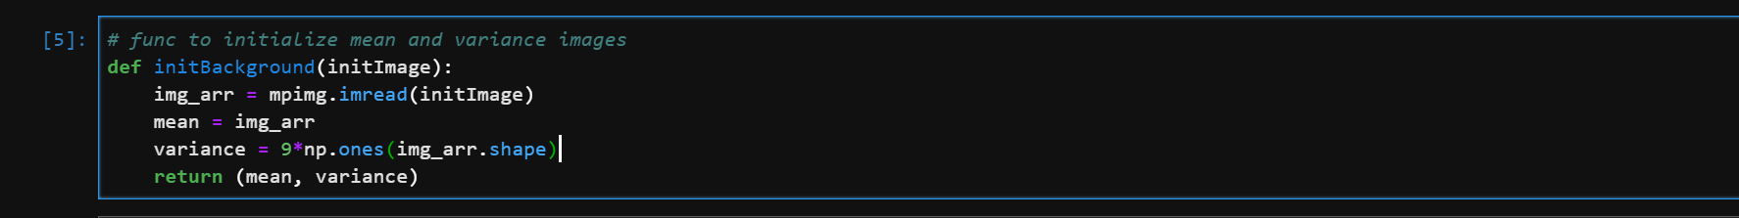

**Reading the image**

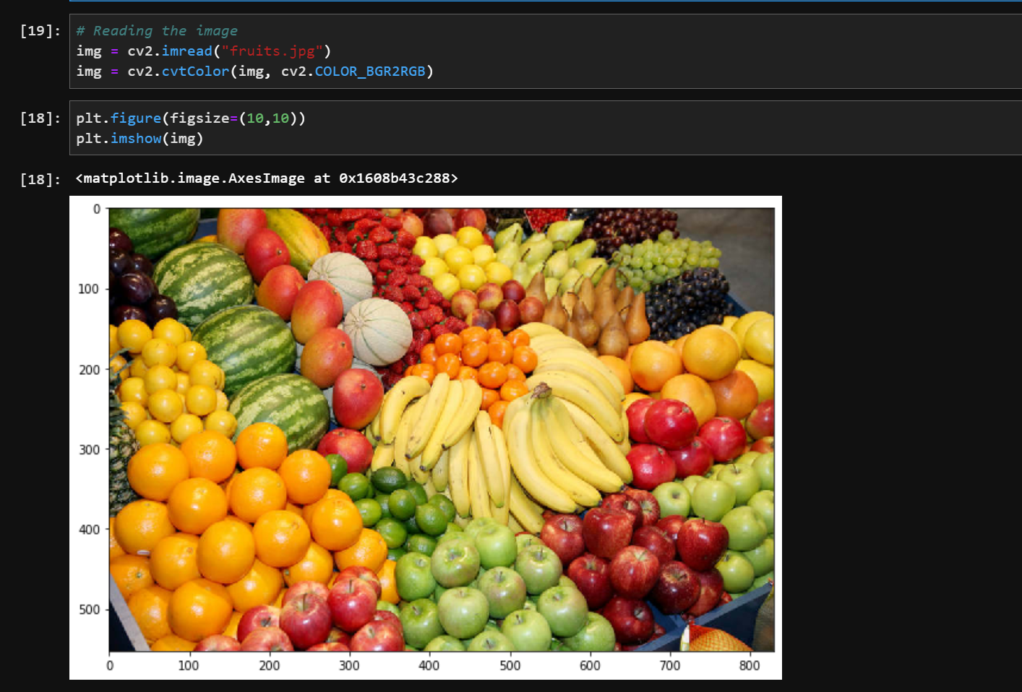

**Classify images into foreground and background pixels using chebyshev inequality**

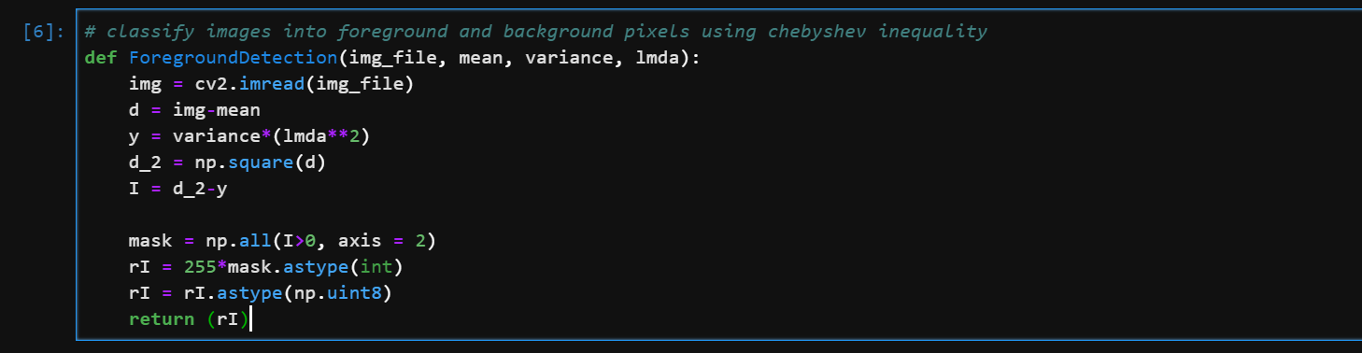

**Reduce the image noise using voting scheme**

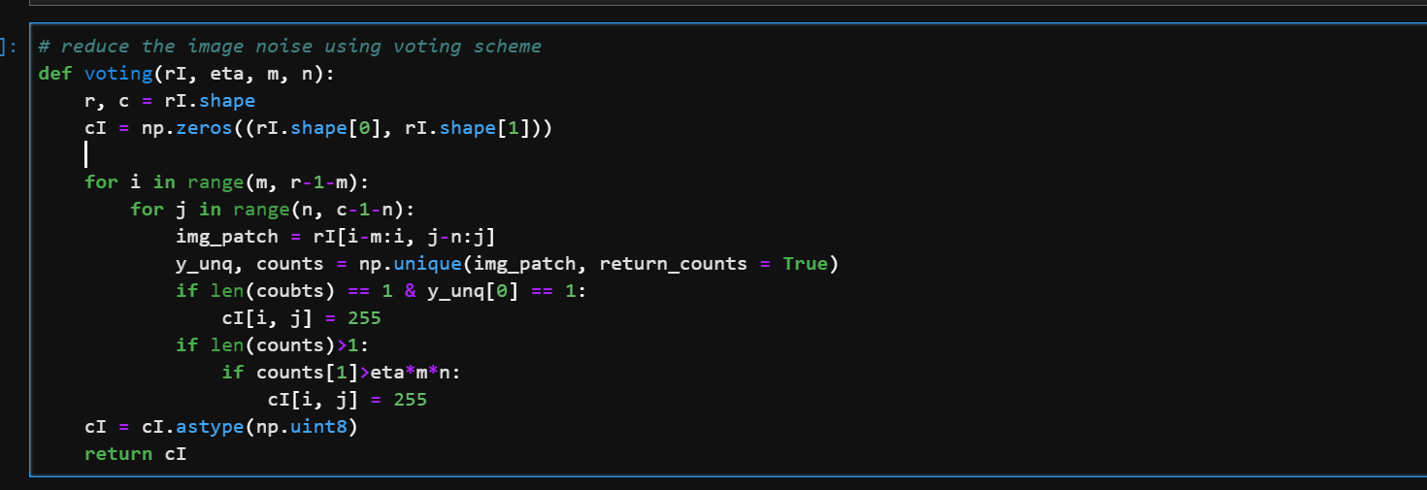

**Update mean and variance images using weighted average scheme**

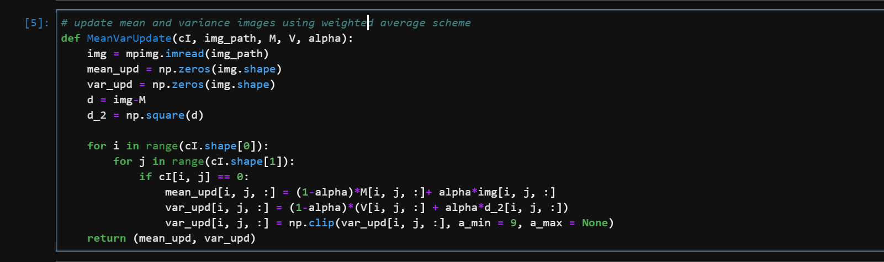

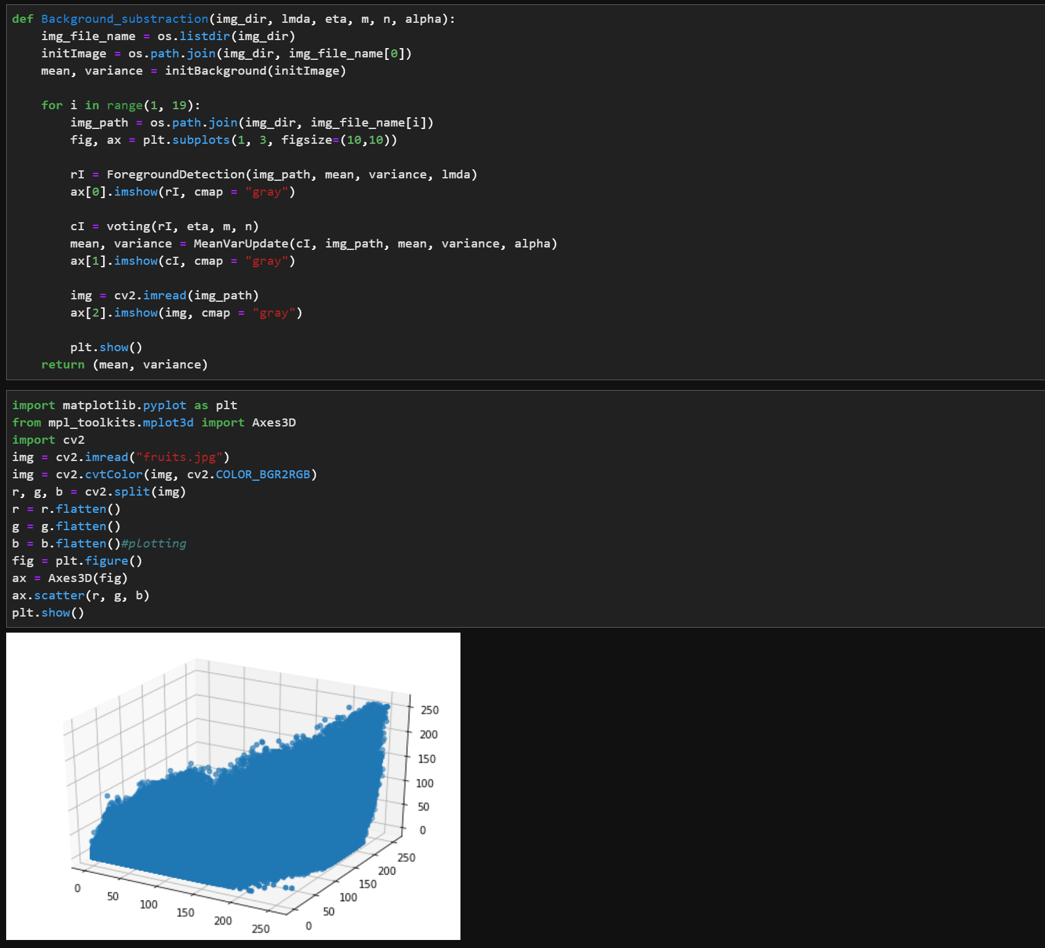

**Output: Segmented image**

